Assignment-1

Assignment-1:WriteaSELECTquerytoretrieveallcolumnsfroma'customers'table,and modifyittoreturnonlythecustomer’snameandemailaddressforcustomersinaspecific city.

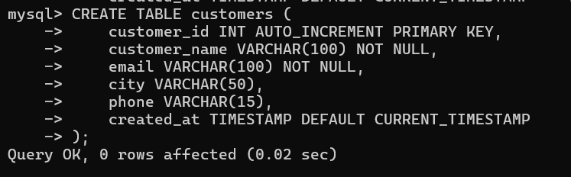CreatingCustomersTable

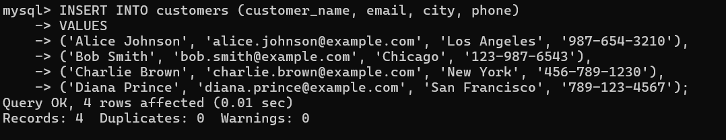InsertingdataintotheCustomerstable:

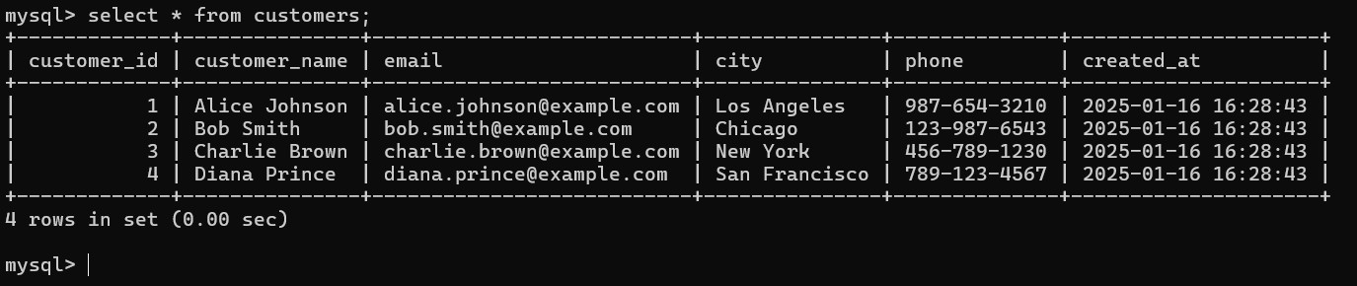RetrieveAllColumnsfromthe'customers'Table

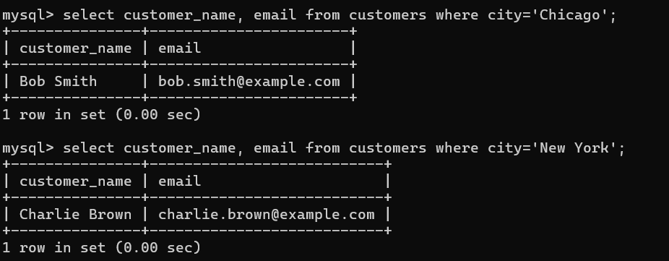RetrieveOnlycustomer_nameandemailforCustomersinaSpecificCity